GPS Simulation Project Report – Kazumi Malhan

This project consists of three source files. The details of each files are described in following section of the report.
- waypoint.cpp – Publish the MarkerArray message to visualize GPS point in Rviz
- vis_path.cpp – Publish the Path message to visualize Audibot’s path history in Rviz
- control.cpp – Publish the Twist message to control the Autibot
waypoint.cpp
In the main function, timer is initialized to publish the GPS waypoint at rate of 20Hz. The param function is used to retrieve the latitude and longitude of reference GPS point, and convert to UTM coordinate format. Next, initializepoint() function is called to convert the each GPS waypoint into UTM coordinate format, and subtract the reference point to get the local waypoint. Finally, new Marker is created and pushed into MarkerArray using for loop. In the timer callback function, time stamp for each marker is updated, then MarkerArray is published as “/waypoint” topic.
vis_path.cpp
In the main function, GPS reference point is retrieved using param function, and converted to UTM coordinates. The node subscribes to “/audibot/gps/fix” topic, and run receive callback function recvFix. In recvFix, reference UTM coordinate is subtracted from current UTM coordinate to calculate the relative position. Current UTM is received by NavSaxFix message. The relative point is added to the path message, time stamp is updated to same time as “/audibot/gps/fix”, and published as “/gps_path” topic.
control.cpp
Approach (Yaw Rate)
First, received vehicle heading is converted from standard GPS heading format (North as 0 degree clockwise) to ROS format (Positive x-axis as 0 radian counter-clockwise) using following equation.
Heading = 450 – GPS heading
if (Heading > 360) => Heading = Heading – 360
Vehicle heading = Heading * M_PI / 180
Then target heading is calculated using atan2 as follow. Also, few logic is added to make sure that the target heading positive angle.
Target heading = atan2(Y target – Y current, X target – X current)
target heading = target heading + (2.0 * M_PI)
target heading = fmod(target heading, 2.0 * M_PI)
Next, heading error is calculated by subtracting vehicle heading from target heading. Here, if the heading error is greater than M_PI, (2.0 * M_PI) is subtracted to keep the heading error less than M_PI. Similarly, if the heading error is less than –M_PI, then (2.0 * M_PI) is added to keep heading error less than - M_PI.
Finally, vehicle yawrate is calculated using following equation, which is derived from forward kinematics of Ackermann drive car. Length is defined as 3.02367
Vehicle yawrate = tan(heading_error) * VehicleSpeed / Length
Approach (Speed)
Speed profile is developed based on the distance to the target GPS point, distance to the previous GPS point, gap between current and previous GPS points, and gap between next and one ahead of next GPS point.
To calculate distance, take x and y difference between GPS point and current point. Then hypot function is used to calculate sqrt(x^2+y^2). Similarly, all other distances are calculated.
The speed profile of Audibot is defined as follow. If it checks that the next GPS point is the last, then speed up to 35 m/s when not dangerous.
Distance | Heading Error | Speed
>= 200 m | < M_PI / 12 | 30 m/s
>= 200 m | < M_PI / 8 | 20 m/s
>= 200 m | Else | 10 m/s
>= 100 m | < M_PI / 12 | 30 m/s
>= 100 m | < M_PI / 8 | 25 m/s
>= 100 m | Else | 15 m/s
>= 30 m | < M_PI / 8 | 25 m/s
>= 30 m | < M_PI / 4 | 20 m/s
>= 30 m | Else | 10 m/s
Distance | GPS gap | Speed
>= 0 m | >= 70 m | 20 m/s
>= 0 m | >= 50 m | 15 m/s
>= 0 m | Else | 10 m/s
Distance Previous | GPS gap Previous | Speed
<= 20 m | >= 65 m | 15 m/s
<= 20 m | Else | 9 m/s

Approach (Switching target GPS point)
GPS point is switched to next point when distance calculated for speed profiling gets less than 1m. Also, when it reaches the last GPS point, Boolean signal called Stop becomes true, sending 0 to both speed and yawrate for complete stop of Audibot.
Approach (Lateral Acceleration Control)
The control logic checks current lateral acceleration coming back from the Audibot, and lateral acceleration of control command that will go to Audibot. The lateral acceleration limit threshold value is defined in launch file. When it detects that lateral acceleration is exceeding the limit, it either limits the yawrate or speed based on distance to the next GPS point to prevent the rollover.
Implementation
The main function first receives the reference GPS points, and convert to UTM coordinate format. Then initalizeWaypoint function is called, which performs converting each GPS waypoint into UTM coordinate and subtract reference point to get local waypoints. After, main function get the acceleration limit parameter defined from launch files. Finally, it subscribes to “/audibot/gps/fix”, “/audibot/gps/heading”, “/audibot/twist” topics and initializes “/audibot/cmd_vel” and timer which run at rate of 50 Hz.
When “/audibot/gps/fix” is received, recvFix callback function is called. The function converts the current GPS point into UTM coordinate format. Then calculate vehicle position in relative to reference point. When “/audibot/gps/heading” is received, recvHeading callback function is called. The function converts the standard GPS heading (North as 0 degree clockwise) into ROS format (Positive x-axis as 0 radian counter-clockwise). The calculation is shown in the Approach (Yaw Rate) section. When “/audibot/twist” received, recvBot callback function is called. The function calculates the actual lateral acceleration of Audibot. (Lateral Acceleration = Speed * Yaw Rate).
The following shows the outline of how timer callback function calculates the yaw rate and speed.
- Calculate the distance between current vehicle position and target GPS points. If the distance is less than 1 m, then switch to the next GPS point as target. Update previous GPS gap. If the previous GPS point was the last one, then make stop signal to true to stop the Audibot.
- Re-calculate the distance between current vehicle positon and target GPS point as it may have changed. Take atan2 to calculate the target heading.
- Calculate heading error by subtracting vehicle heading from target heading. Make sure to have absolute heading error less than M_PI.
- Calculate the distance between current vehicle positon and previous GPS point. If there is no previous GPS point, then make it 100 m.
- Calculate GPS gap between target GPS point and the one after the target GPS point. If there is not next GPS point, assign 1000 m.
- Make vehicle speed to default speed of 10 m/s. Then go through the speed profile explained in Approach (Speed) section to apply appropriate speed.
- Calculate the yaw rate based on the equation explained in Approach (Yaw Rate) section.
- Check the lateral acceleration to make sure that the rollover doesn’t happen. First it check for current combination of speed and yaw rate command, then checks for actual lateral acceleration coming back from the Audibot.
- If stop signal is true, overwrite the speed and yaw rate into 0.
- Assign the speed to cmd_vel.linea.x and yaw rate to cmd_vel.angular.z, then publish the topic.

rqt_graph
The following shows the screenshot of rqt_grap while system is running.
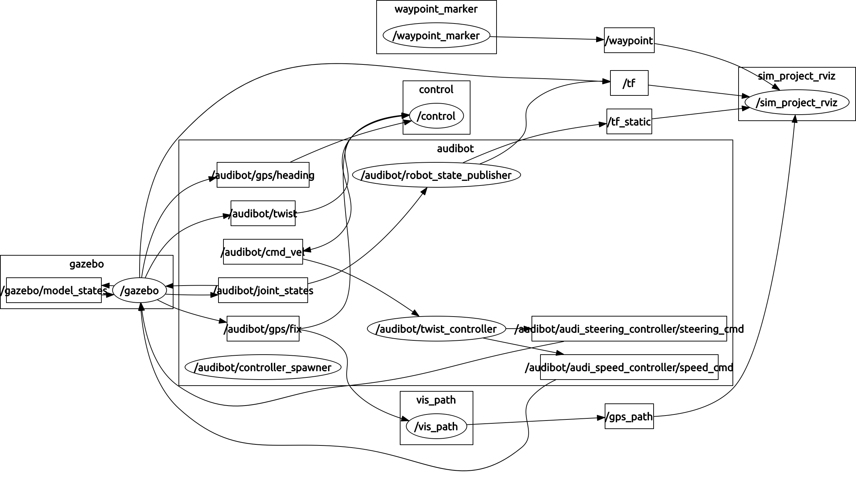
Screenshot of Test Pass
Test run indicated that Audibot completes the all GPS points in around 57.2 seconds without rollover.
